# **Individual Class analytics page**

**Purpose of interaction being evaluated.**

The class analytics page is where students will be able to check in on their progress for a specific class compared to other classmates.

**Insert image of interaction being evaluated.**

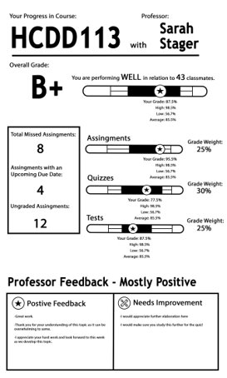

# **Evaluation**

|  |  |  |  |
| --- | --- | --- | --- |
|  | **Severity (1-5)** | **Evaluation Notes** | **Design Changes** |
| **Visibility of system status** | 1 | Keeps user informed about what is going on, through appropriate feedback within reasonable time. | Slightly less clutter |
| **Match between system and real world** | 1 | speak the users' language, with words, phrases and concepts familiar to the user, rather than system-oriented terms. | Make information appear in slightly more logical order |
| **User control and freedom** | 3 | Can select course but no redo or under button | Redo and undo button |
| **Consistency and standards** | 1 | Follows platform conventions | Slightly different phrasing |
| **Error prevention** | 1 | Careful design which prevents problems from occurring | Confirmation option |
| **Recognition rather than recall** | 1 | Instructions for use of the system is visible and easily retrievable | More visible objects |
| **Flexibility and efficiency of use** | 1 | Caters to both new and experienced users | Allow more tailored actions |
| **Aesthetic and minimalist design** | 1 | Simple and minimalistic design | Slightly less clutter |
| **Help users recognize, diagnose, recover from errors** | 5 | No error message prompt seen | Error message prompt |
| **Help and documentation** | 5 | No help and documentation seen | Easy to find help and documentation |

# **Opening Page**

**Purpose of interaction being evaluated.**

This service would take the information from each course’s canvas page and give the student the opportunity to organize it based on what best suits them.

Insert image of interaction being evaluated.

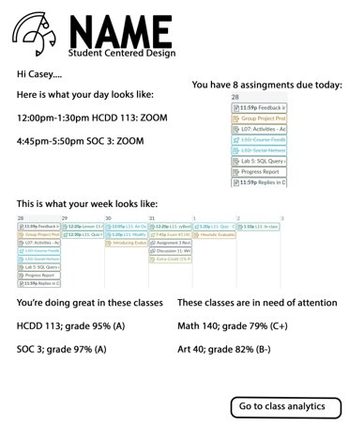

# **Evaluation**

|  |  |  |  |
| --- | --- | --- | --- |
|  | **Severity (1-5)** | **Evaluation Notes** | **Design Changes** |
| **Visibility of system status** | 2 | keep users informed about what is going on, through appropriate feedback within reasonable time. | More visually appealing |
| **Match between system and real world** | 2 | speak the users' language, with words, phrases and concepts familiar to the user, rather than system-oriented terms | Make important words have different colors |
| **User control and freedom** | 5 | Don’t see undo or redo buttons | Undo or redo buttons |
| **Consistency and standards** | 1 | Follow platform conventions | Color important words |
| **Error prevention** | 5 | No error prevention | Include error preventions |
| **Recognition rather than recall** | 1 | Minimizes the user's memory load by making objects, actions, and options visible. | More visible instructions |
| **Flexibility and efficiency of use** | 3 | caters to both inexperienced and experienced users. | Easier to navigate layout |
| **Aesthetic and minimalist design** | 3 | Visually appealing | Less clutter, more colors, bigger words. |
| **Help users recognize, diagnose, recover from errors** | 5 | No error message prompt | Error message prompt |
| **Help and documentation** | 5 | No help and documentation prompt | Help and documentation prompt |